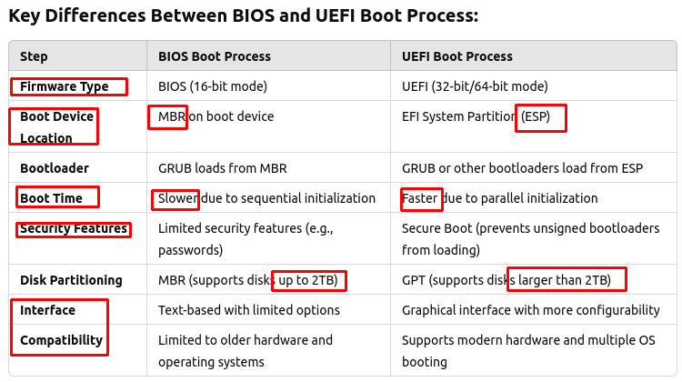
Necessary modules to read /boot/grub is already embedded in bootloader (grubx64.efi ot shimx64.efi)
================================================================

DISK CONTAINS BOOT AREA
BIOS – a disk contains MBR
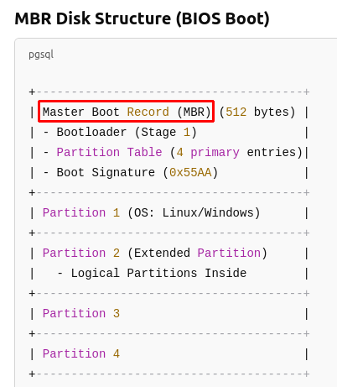

UEFI – a GPT-formatted disk contains ESP (GPT – GUID partition table)

=======================================================================
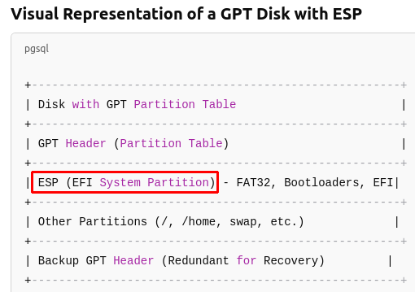
=======================================================================

BOOTING TIME
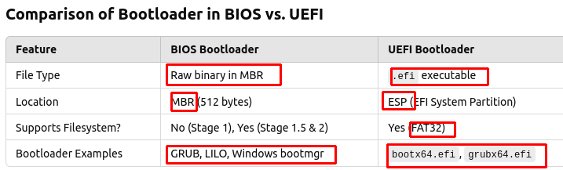
+ BIOS → load MBR → load GRUB (raw binary)
+ UEFI → read ESP → load bootloader (.efi) → faster

